**VIEWS**

**SELECT *FROM EMPLOYEE;**

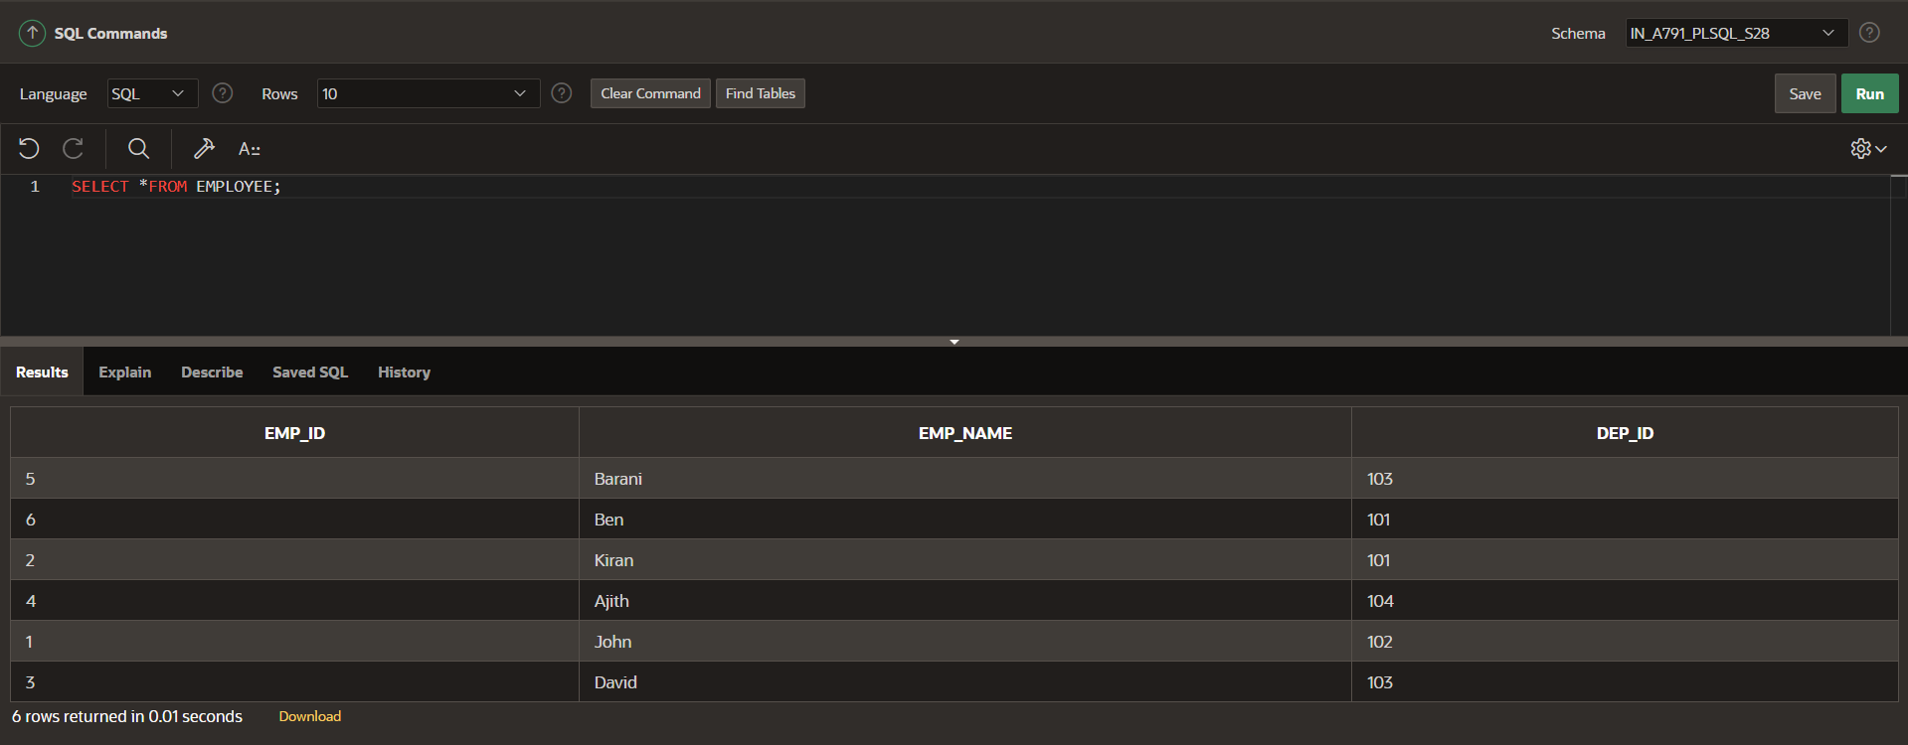

**SELECT *FROM DEPARTMENT;**

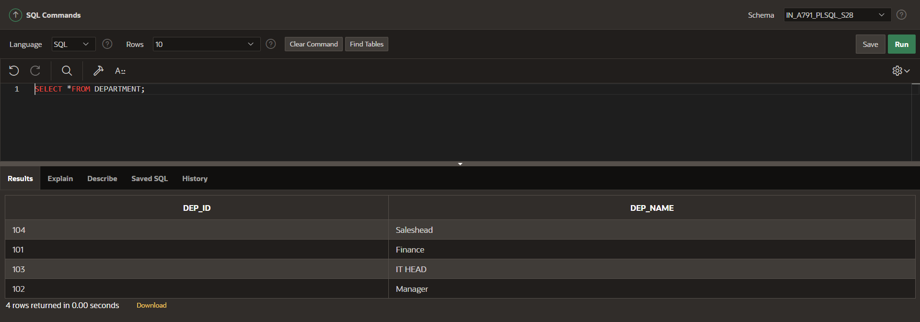

**INNER JOIN:**

**SELECT EMP_ID,EMP_NAME,DEP_NAME FROM EMPLOYEE INNER JOIN DEPARTMENT ON EMPLOYEE.DEP_ID=DEPARTMENT.DEP_ID;**

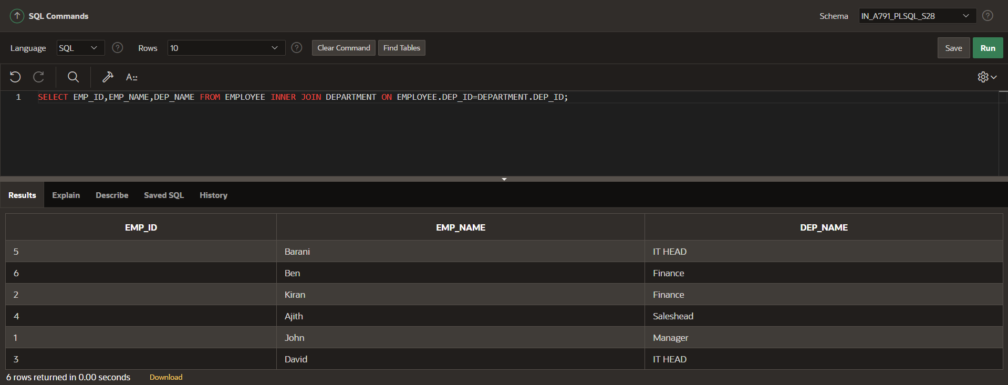

**CREATE VIEW EMP_DETAIL AS**

**SELECT EMP_ID,EMP_NAME,DEP_NAME FROM EMPLOYEE INNER JOIN DEPARTMENT ON EMPLOYEE.DEP_ID=DEPARTMENT.DEP_ID;**

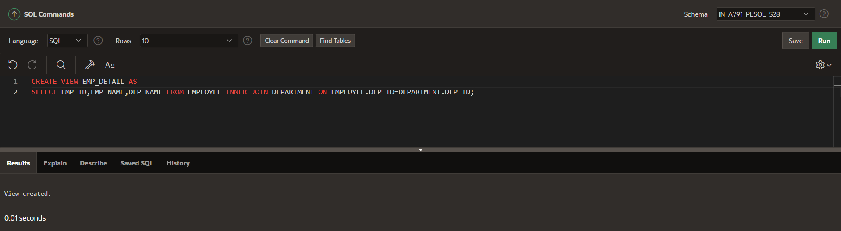

**SELECT *FROM EMP_DETAIL;**

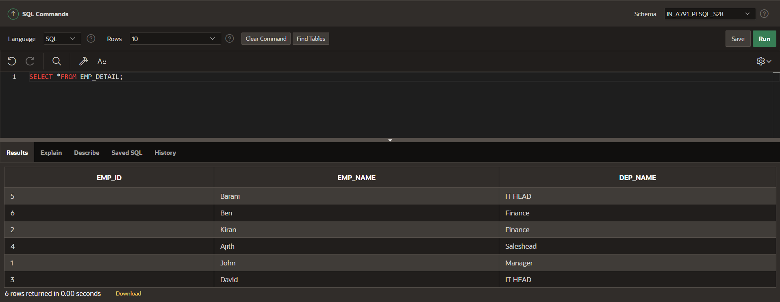

**SELECT *FROM EMP_DETAIL WHERE DEP_NAME='Finance';**

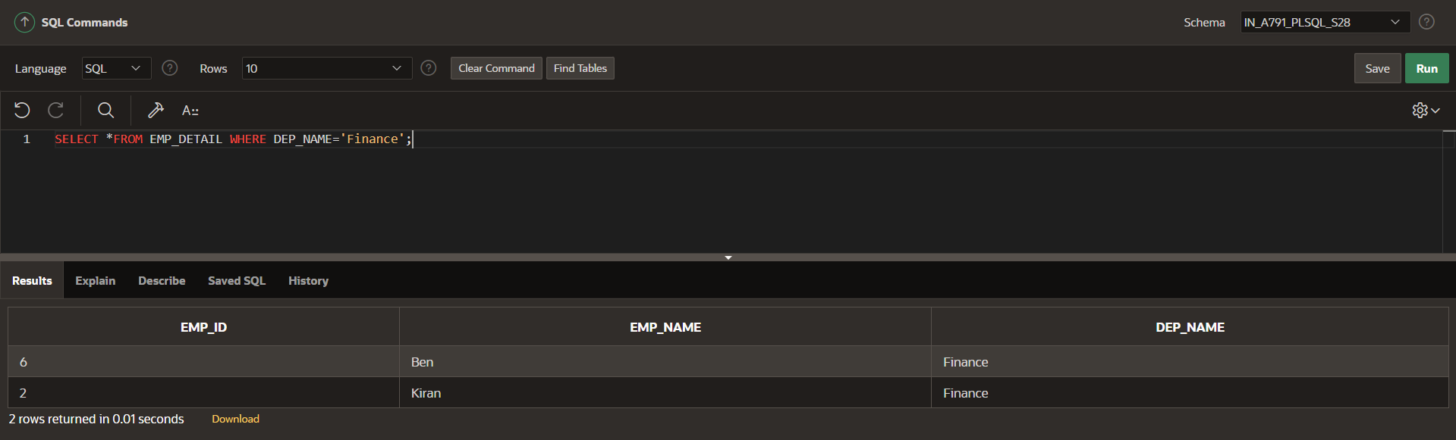

**CREATE OR REPLACE VIEW EMP_DETAIL AS**

**SELECT EMP_ID,EMP_NAME,DEP_NAME FROM EMPLOYEE INNER JOIN DEPARTMENT ON EMPLOYEE.DEP_ID=DEPARTMENT.DEP_ID ORDER BY EMP_ID;**

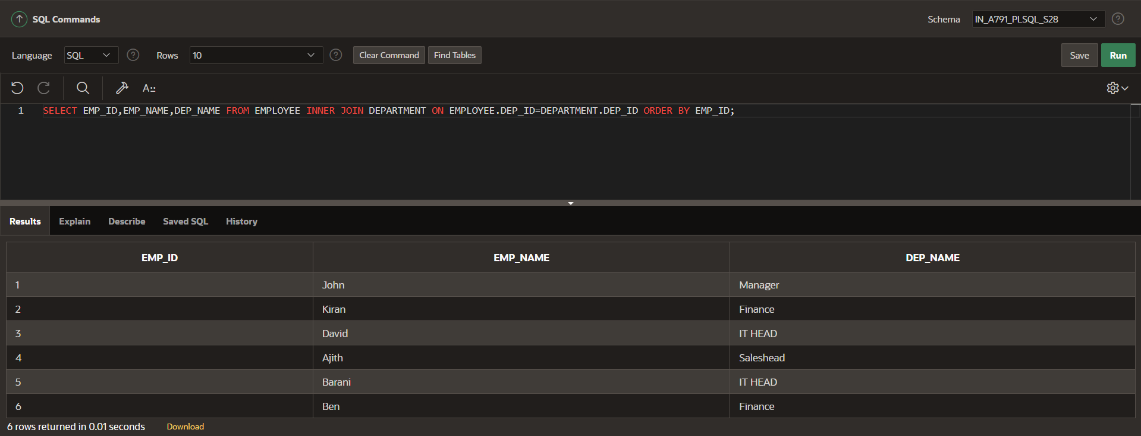

**DROP VIEW EMP_DETAIL;**

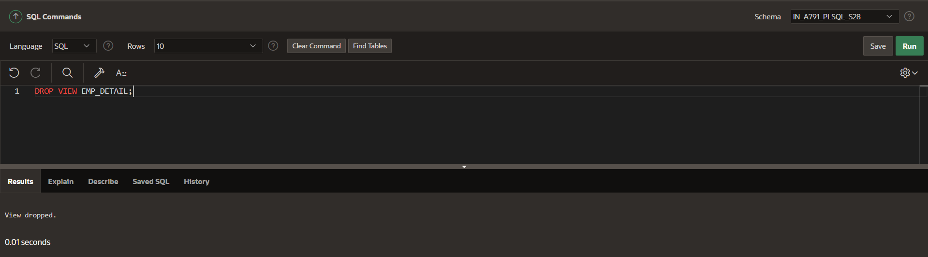

**SEQUENCE**

**CREATE SEQUENCE seq1**

**START WITH 1**

**INCREMENT BY 1**

**MINVALUE 1**

**MAXVALUE 5;**

**SELECT seq1.nextval FROM dual;**

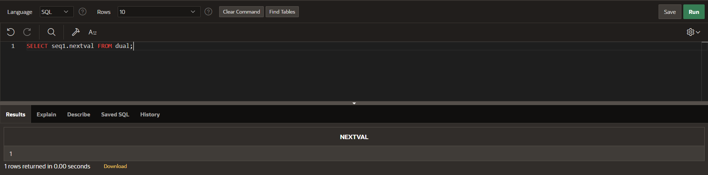

**SELECT seq1.nextval FROM dual;**

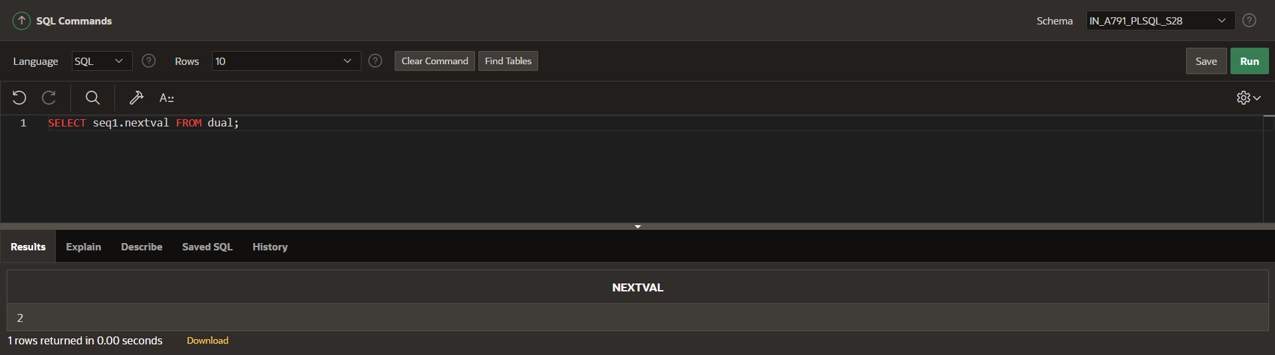

**SELECT seq1.nextval FROM dual;**

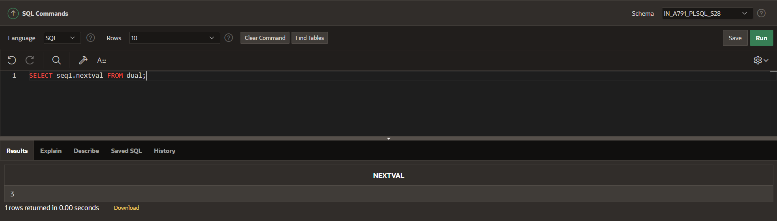

**SELECT seq1.nextval FROM dual;**

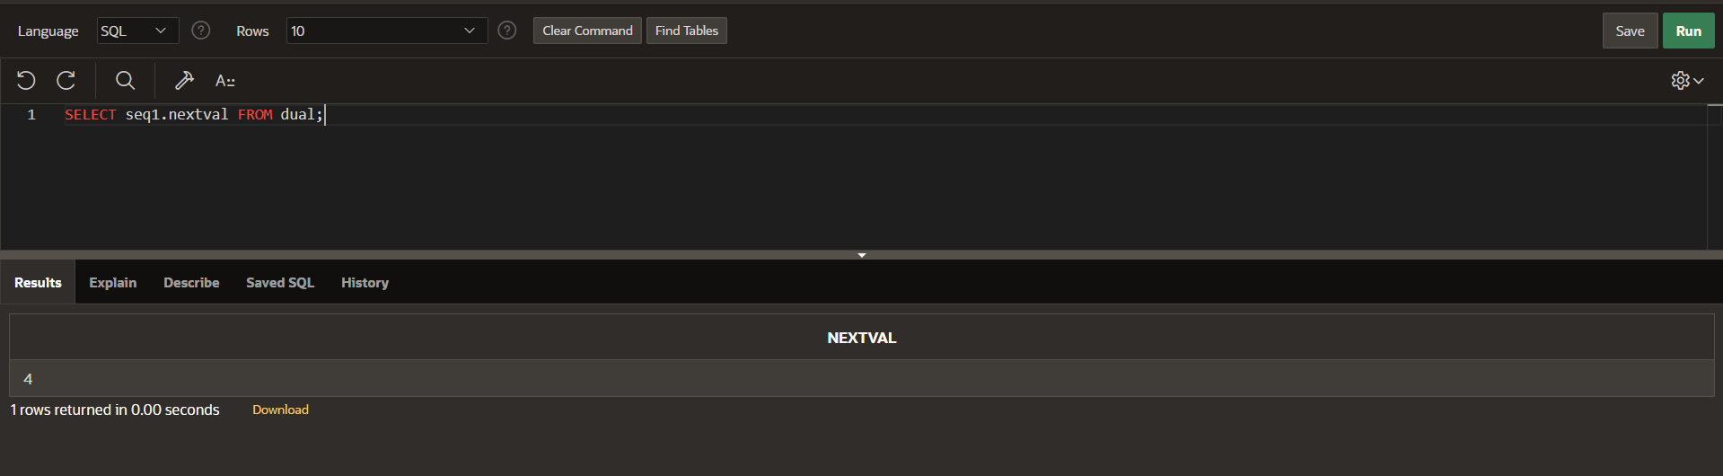

**SELECT seq1.nextval FROM dual;**

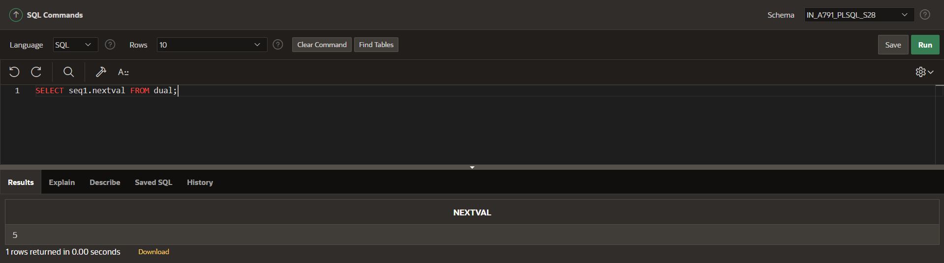

**THE MAXVALUE SHOULD BE REACHED**

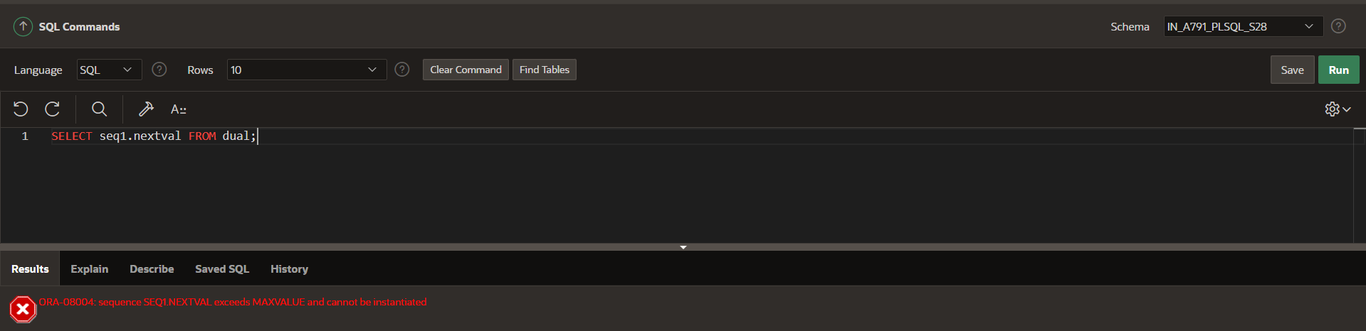

**DROP THE SEQUENCE**

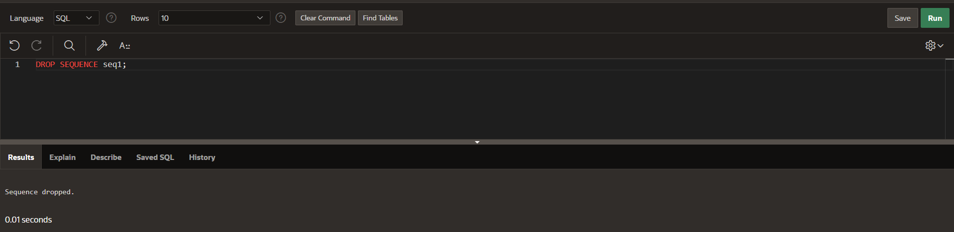

**YOU SHOULD CONTINUE THE SEQUENCE MUST FIND THE CACHE.**

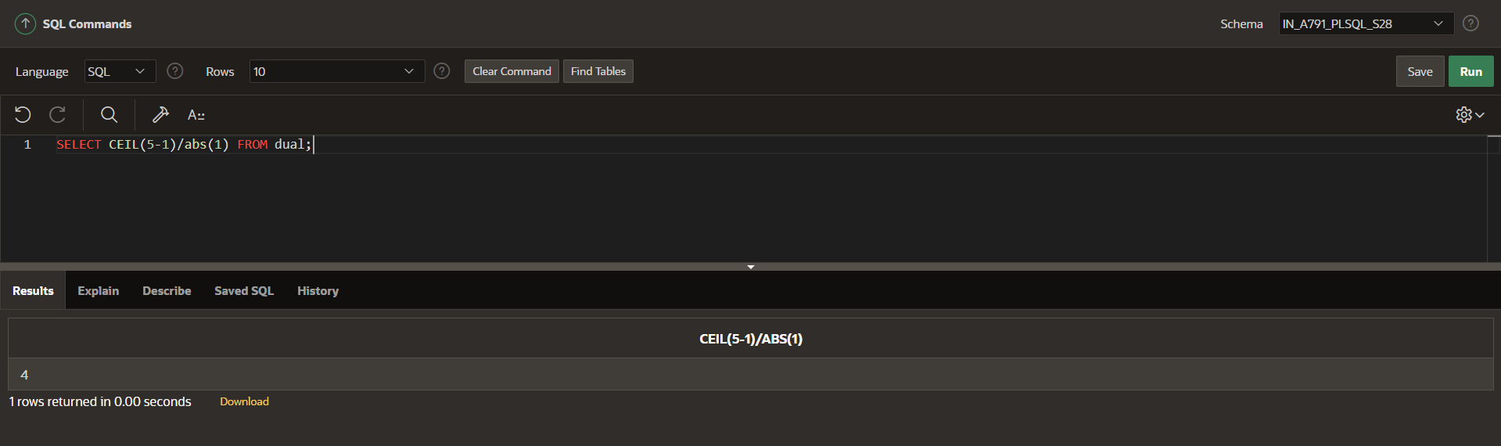

**AFTER**

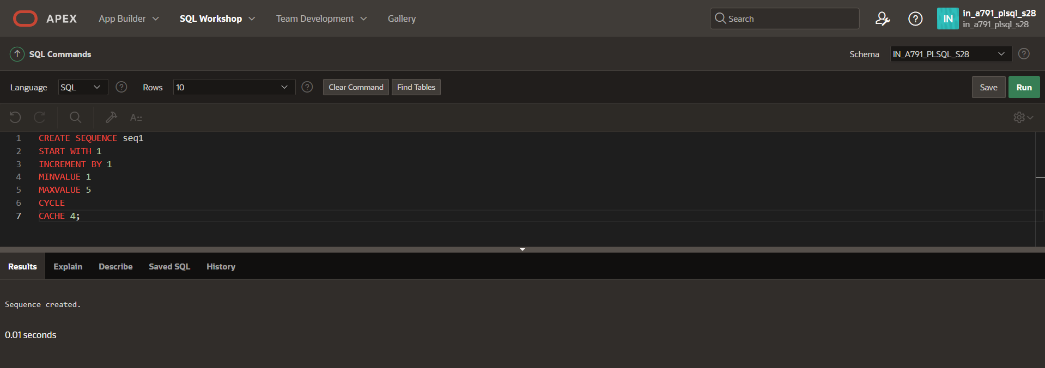

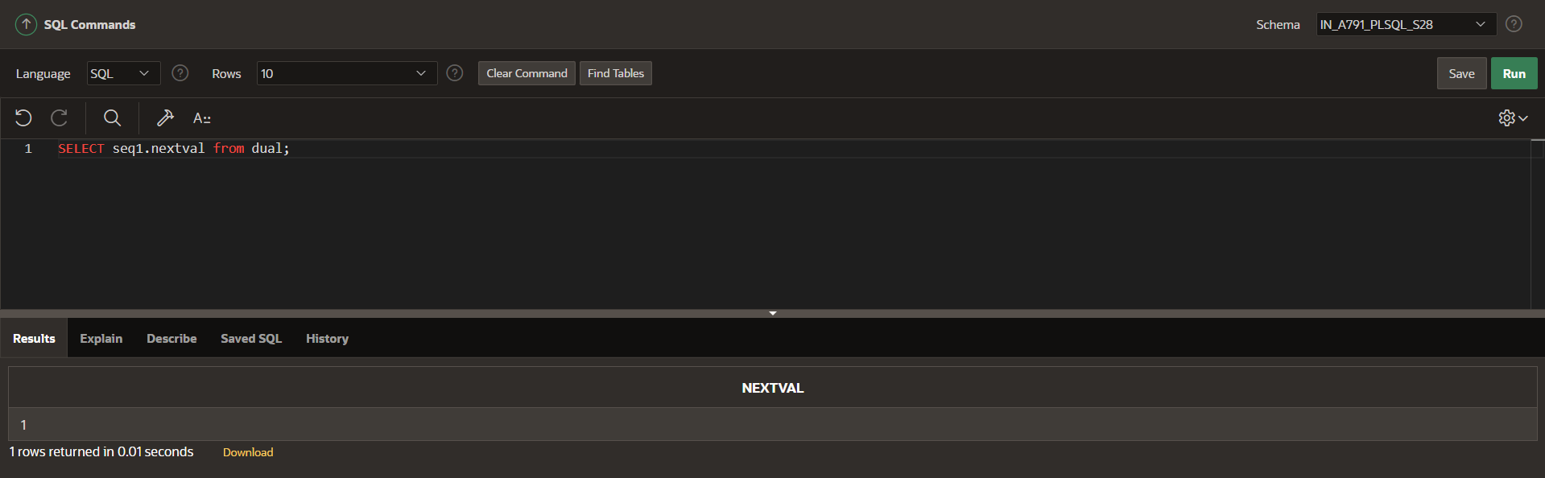

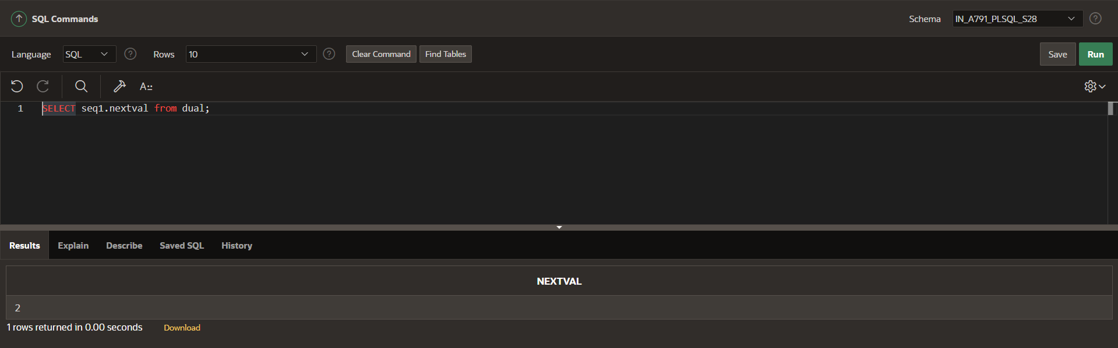

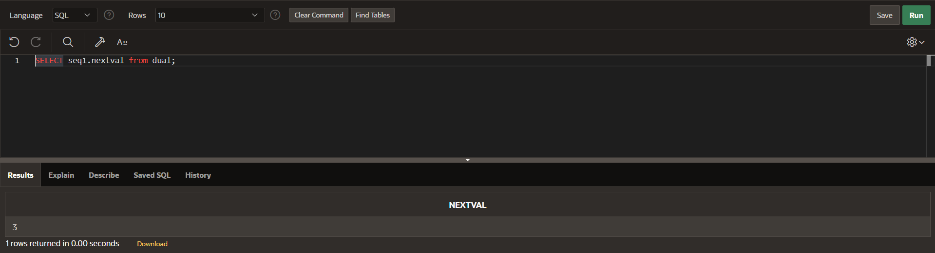

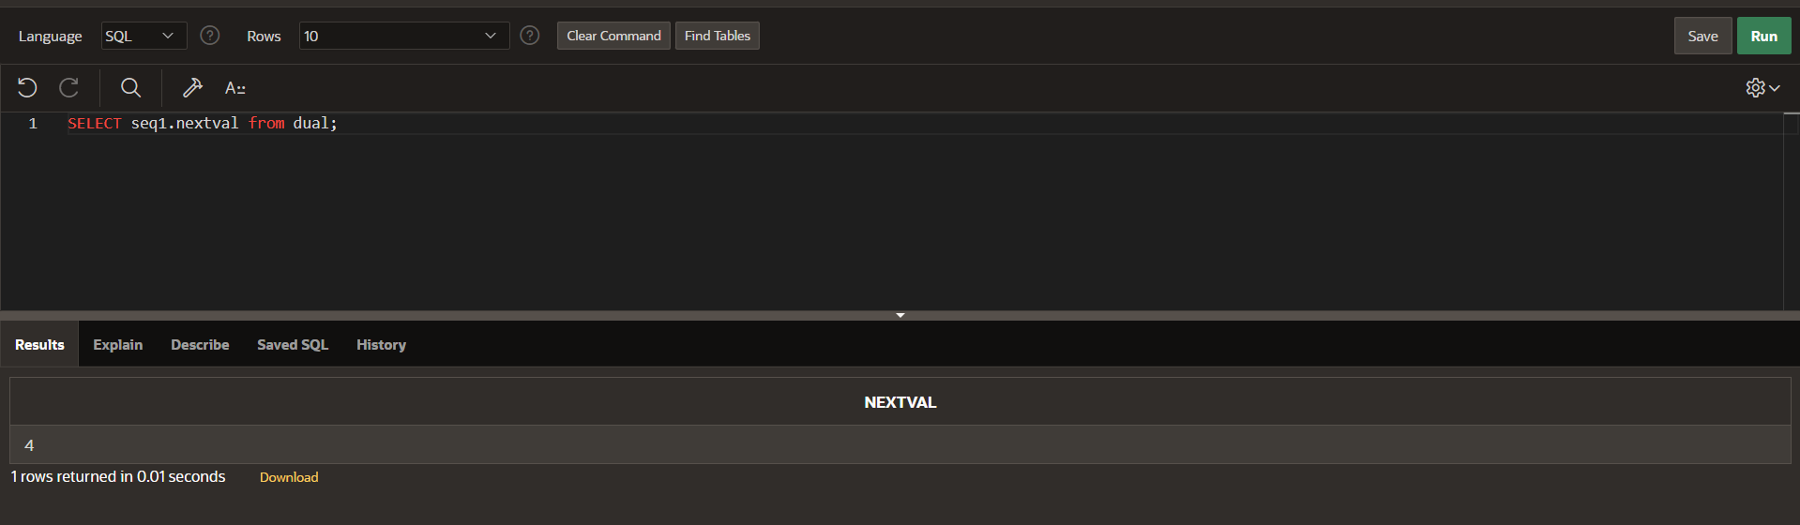

**CURRENT VALUE:**

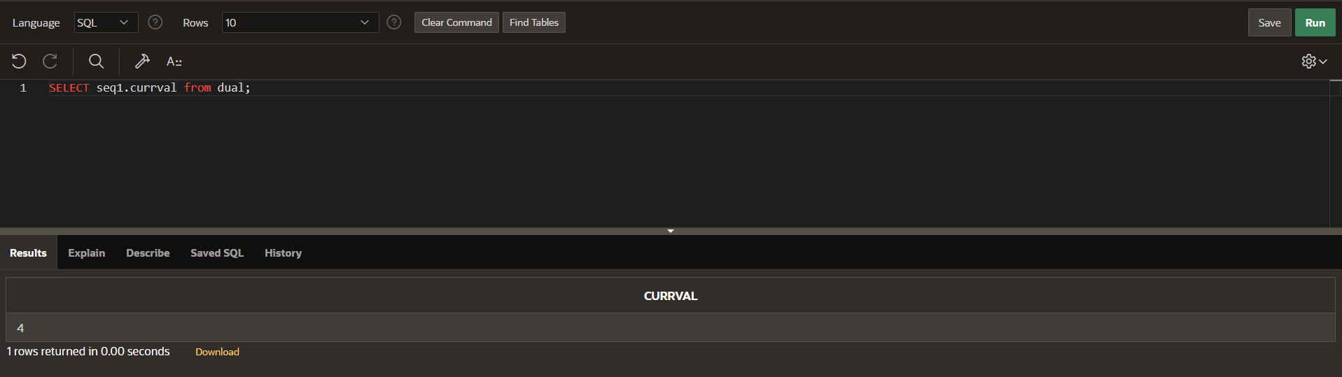

**NEXT VALUE:**

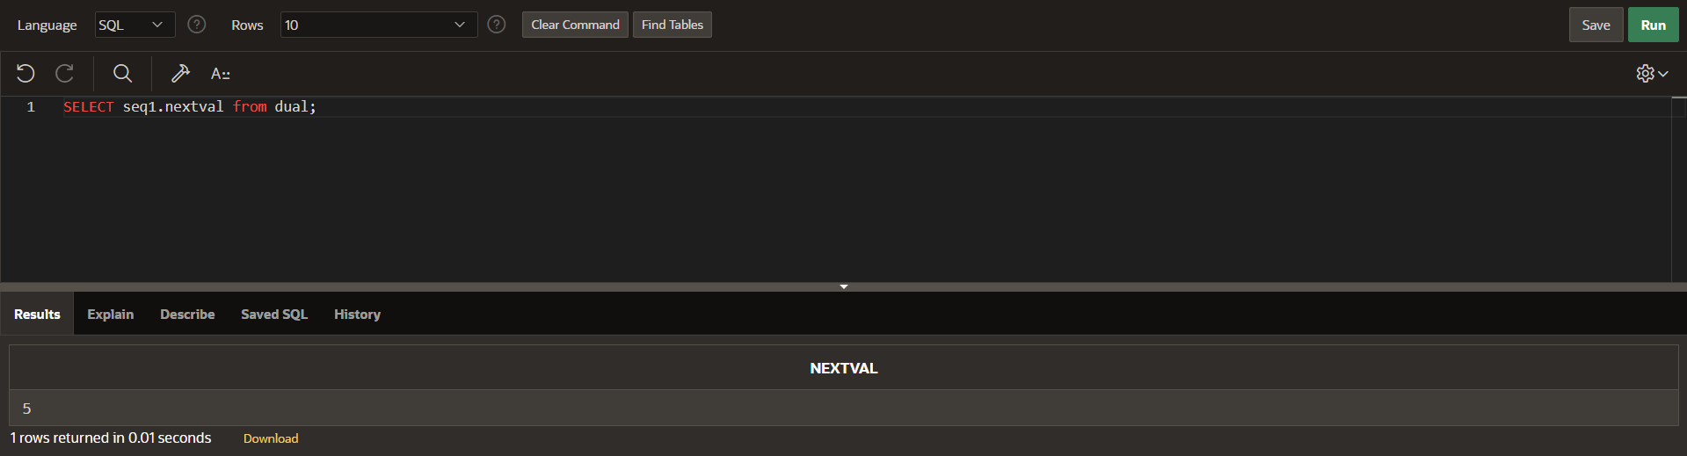

**IT START WITH 1 BECAUSE THE CYCLE AND CACHE ARE INVOLVED IN THE SYNTAX.**

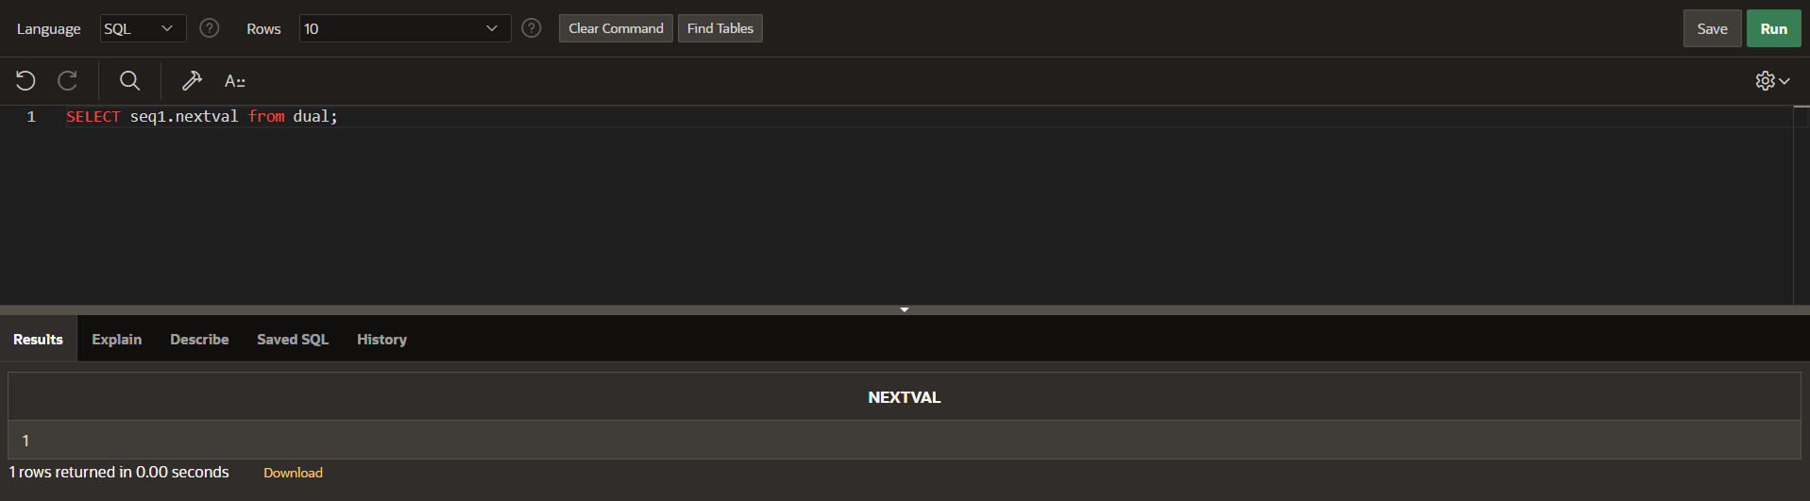

**SYNONYM**

**SELECT *FROM STUDENT_DETAIL ORDER BY STU_ID;**

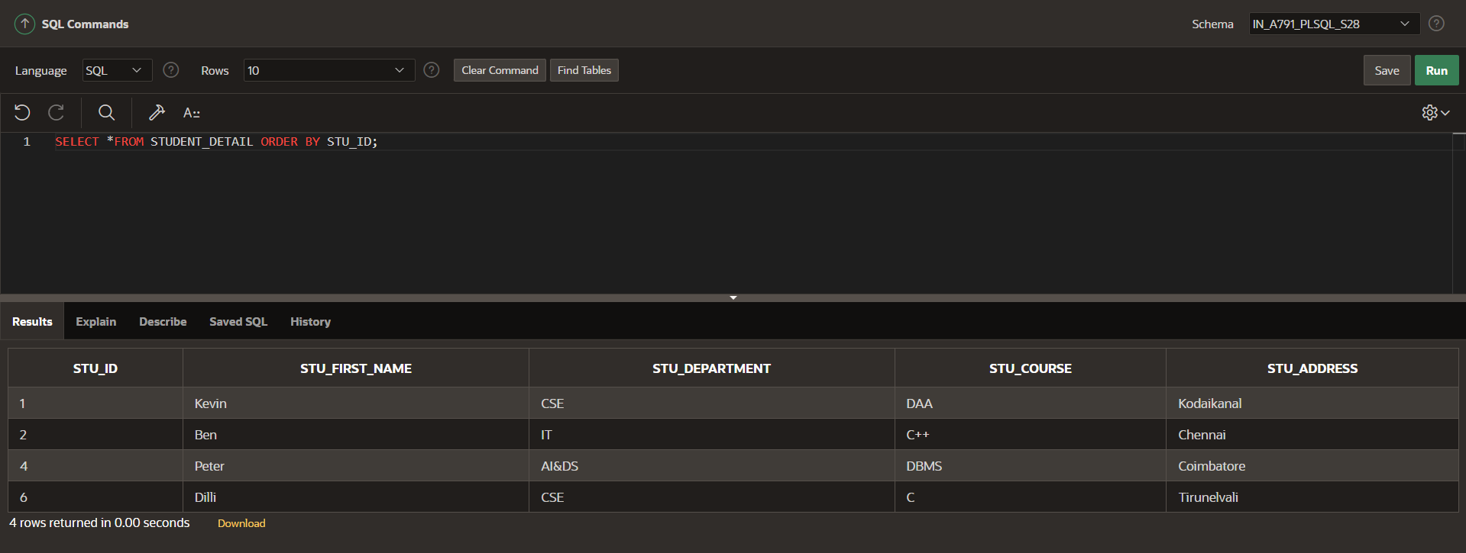

**CREATE SYNONYM ST_DE FOR STUDENT_DETAIL;**

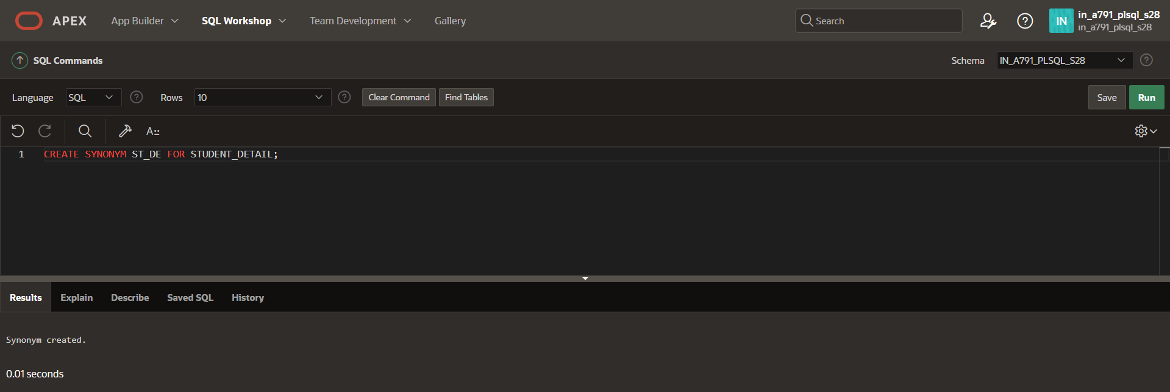

**SELECT *FROM ST_DE;**

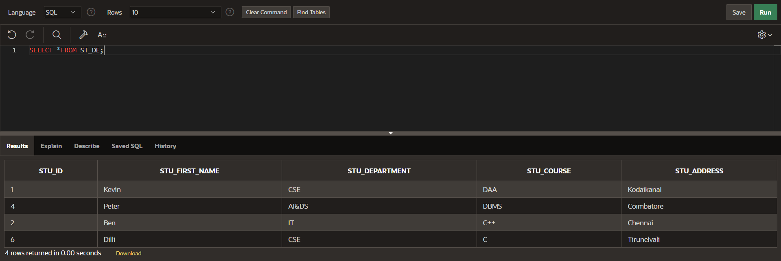

**INSERT INTO ST_DE VALUES (7,'Ajith','AIML','OS','Trichy');**

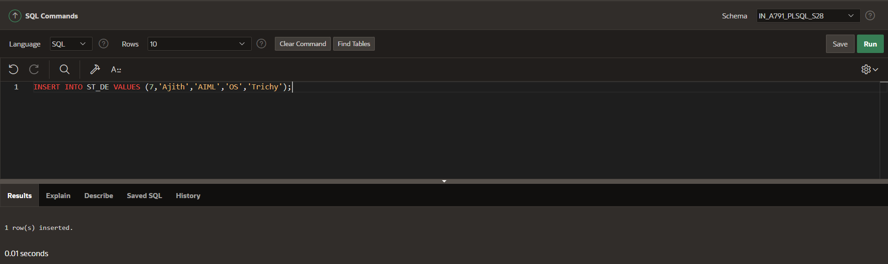

**SELECT *FROM ST_DE;**

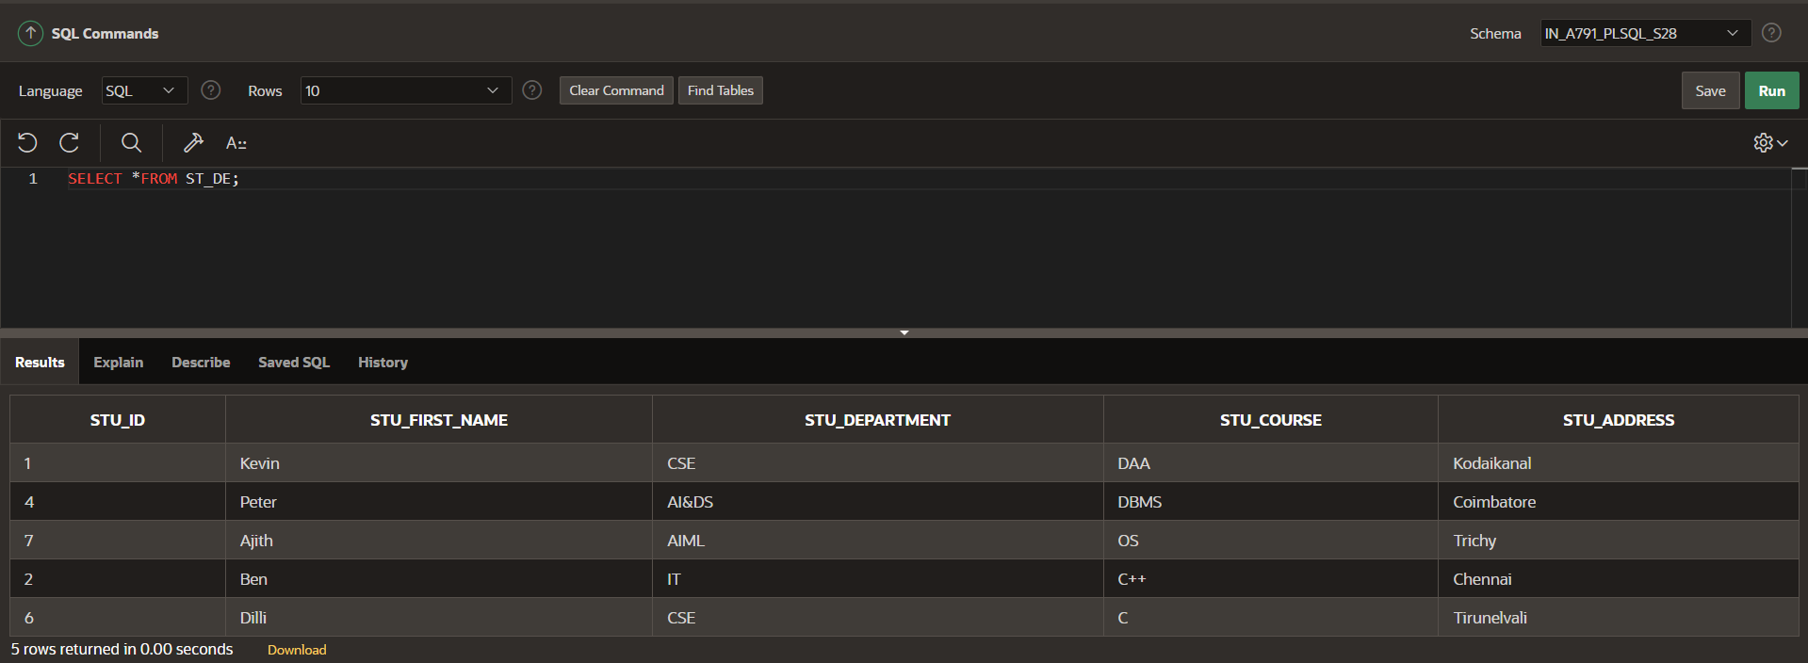

**DROP:**

